**User story for sprint 2**

**List Members:**

**Hoàng Bảo Vy**

**Tống Thị Trâm**

**Nguyễn Minh Châu**

**Phạm Huy Hoàng**

**Nguyễn Đức Thắng**

1. **Manage Categories**

* Card

As an administrator, I want to manage categories of product, so that I can add new categories, delete it if it is no longer in use and edit it if necessary.

* Conversation
* Add new categories manually
* Display information in table
* Sorted categories list – based on id, name, image, category, type, location, status: to find information more easily.
* Confirmation
* Add, edit and delete categories manually.
* Display all categories details in a table, sorted by id, name, image, category, type, location status.
* Display an error when:

1. Add Categories

- One of the user’s information(Name, price, image, categories, type, location, status.) is blank. Prompt “Please enter the missing field”.

2. Edit Categories

- One of the categpries’s details(name, price, image, categories, type, location, status.) is blank. Prompt “Please enter the missing field”.

3. Delete categories

None.

* Scenarios

1. Add Categories:

* Click button manage categories
* Enter catalog ’s information (Name, Email address, Password and Re-enter password)
* System roues user to dashboard page

1. Edit Categories :

* Select a categories
* Change the information of the categories ’s information (name, price, image, categories, type, location, status)
* Confirm categories information update (e.g by clicking “Update information”)
* System confirms a confirmation message

1. Delete Catalog:

* Click Delete button in one user’s table row
* System asks Admin to confirm deletion
* Click Yes
* System displays a message confirming the successful deletion.

Mockup for manage categories:

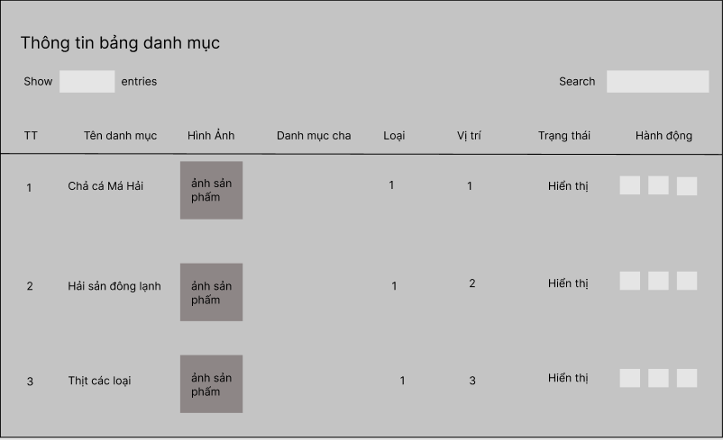

1. **Manage Users:**

* Card

As an administrator, I want to manage users, so that I can add a new user, delete it if it is no longer inusse and edit it if necessary.

* Conversation
* Admin: They want to add, edit, delete categories with id, name, phone number, email, description. date created so they can manage your user.
* They must enter in the required field valid email and name that can not be empty.

+ name : exceeds 30 characters

+ email: correct email format

+ password: is less than 8 characters

* Button: “Act”
* After successfully, the admin can see all information about the user.
* Confirmation
* Add, edit and delete user manually
* Display all users' details in one table, sorted by name, email address, date created and description.
* Display an error when:

1. Add user:

* One of the user’s information(Name, email, password) is blank. Prompt “Please enter the missing field”.
* Name exceeded 30 characters. Prompt “Name exceeds the allowed characters”
* Email address in invalid. Prompt “Invalid email address”.
* Email addresses already existed in the database. Prompt “This email address has been taken”.
* Password and re-enter password do not match”.
* Password is less than 8 characters”.

1. Edit user:

* One of the user’s details (Name, email) is blank. Prompt “Please enter the missing field”.
* Name exceeded 30 characters. Prompt ‘Name exceeds the allowed characters’
* Email addresses already existed in the database. Prompt ‘This email address has been taken’.

1. Delete user

None

* Scenarios

1. Add User:

* Click Register in login page
* Enter user’s information (Name, Email address, Password and Re-enter password)
* System routes user to dashboard page

1. Edit User:

* Select a user name
* Change the information of the user’s information (name and email addresses)
* Confirm user info update (e.g by clicking “Update information”)
* System confirms a confirmation message

3. Delete User:

* Click Delete button in one user’s table row
* System asks Admin to confirm deletion
* Click Yes
* System displays a message confirming the successful deletion.

Mockup for Manage User:

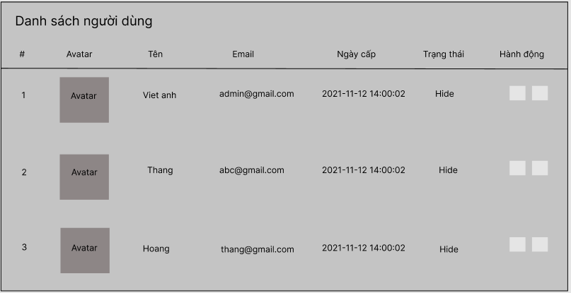

**3. Management product**

* Card

As an administrator, I want to manage products, so that I can add product’s information, remove it if it is no longer in use and edit it if necessary.

* Converation
* Add new product manually
* Admin: they must add, edit, delete product with id, name, image, categories, creator,location, original price, promotion price, hot product, status.
* Required field: name, image, original price.
* Button “Act”
* Confirmation
* Add product manually including id, name, image, categories, creator, location, original price, promotion price, hot product, status.
* Display product information in table sorted by id, name, image, categories, creator, location, original price, promotion price, ho product, status.
* View, edit, delete function are also necessarily added
* Display an error when:

1. Add Product

* Name product is blank, prompt “Please enter the product name”.
* Image product is blank, prompt “Please add the image product”.
* Original price product is blank, prompt “Please enter the original product”.

1. Edit Product

* Name product is blank, prompt “Please enter the product name”.
* Image product is blank, prompt “Please add the image product”.
* Original price product is blank, prompt “Please enter the original product”.

1. Delete product

None.

* Scenarios

1. Add product

* Click “Act”, select “create”
* Enter the textbox of the id, name, image, categories, creator, location, original price, promotion price, ho product, status.
* Click “Add” to create the class with some information.

1. Edit product:

* Select a certain row and click ‘Edit’
* Change the information of the product’s selected
* Click “Save change” to confirm the edition

1. Delete product:

* Click the Delete button in one class’s table row.
* The system will ask the Admin whether he/she confirms removal or not.
* Click “Confirm to yes”.
* System displays a message confirming the successful deletion.

Mockup for manage Product

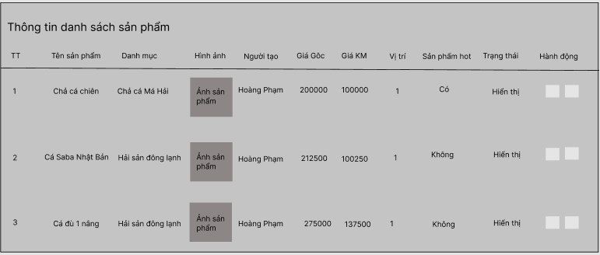

**4. Manage Posts**

* Card

As an administrator, I want to manage posts, so that I can add some posts, remove it if it is no longer in use and edit it if required

* Conversation
* Add new product manually
* Admin: they must id, title, image, description, author, categories, status.
* Required field: name, image, description.
* Button “Act”
* Confirmation
* Add posy manually including id, title, image, categories, author, status.
* Display post information in a table sorted by id, title, image, categories, author, status.
* View, edit, delete function are also necessarily added
* Display an error when:

1. Add Posts

* Title is blank, prompt “Please enter the title”
* Image is blank, prompt “Please add the image”
* Description is blank, prompt “Please enter the description”

1. Edit Posts

* Title is blank, prompt “Please enter the title”
* Image is blank, prompt “Please add the image”
* Description is blank, prompt “Please enter the description”

1. Delete Posts

None.

* Scenarios

1. Add posts

* Click “create post”
* Enter the textbox of the id, name, description, image, …
* Click “Add” to create the class with some information.

1. Edit post:

* Select a certain row and click ‘Edit’
* Change the information of the post’s selected
* Click “Save change” to confirm the edition

1. Delete post:

* Click the Delete button in one class’s table row.
* The system will ask the Admin whether he/she confirms removal or not.
* Click “Confirm to yes”.
* System displays a message confirming the successful deletion.

Mockup for Manage Post

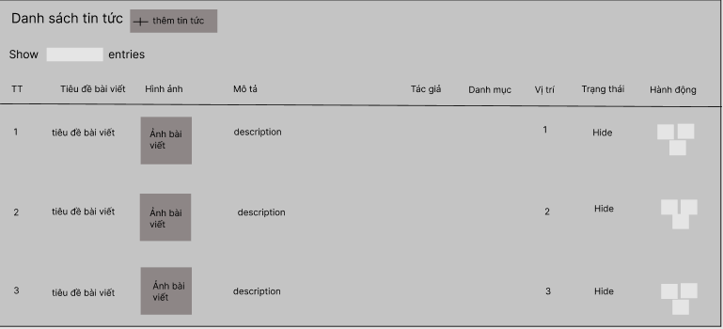

**5. Manage order**

* Card

As an administrator, I want to manage order, so that I can view product that ordered by customer.

* Conversation
* Display all information of order : id, date, id customer, status, name, phone number, email, total price.
* Confirmation
* Navigate to manage order after enter button manage order
* View all order information: id, date, id customer, status, name, phone number, email, total price.
* Display error messages when:

None

* Scenarios:
* Open manage order tab
* View list of order.

Mockup for manage order:

